**University of California, Berkeley – College of Engineering**Department of Electrical Engineering and Computer Sciences

Fall 2014 Instructor: Gerald Friedland 2014-10-01

# CS10 QUEst

|  |  |  |
| --- | --- | --- |
| ***Last*** *Name (Please print clearly)* |  | |
| ***First*** *Name (Please print clearly)* |  | |
| *Student ID Number* |  | |
| *Circle the name of your Friday Discussion TA* | **Adam   Andy   Arany   Jaclyn   Janna   Joseph   Jeffrey**  **Max Rachel Sumer Steven Victoria** | |
| *What time is your discussion on Friday?* |  | |
| *Name of the person to your: Left | Right* |  |  |
| *All my work is my own. I had no prior knowledge of the exam contents nor will I share the contents with others in CS10 who haven’t taken it yet.* ***(please sign)*** |  | |

**Instructions**

* Don’t Panic! This booklet contains 6 pages including this cover page. Put all answers on these pages; don’t hand in any stray pieces of paper.
* Please turn off all pagers, cell phones and beepers. Remove all hats and headphones.
* You have 50 minutes to complete this exam. The quest is closed book, no computers, no PDAs, no cell phones, no calculators, but you are allowed one double-sided paper of notes. There may be partial credit for incomplete answers; write as much of the solution as you can. When we provide a blank, please fit your answer within the space provided. We drop the next page’s lowest-scoring question. ☺
* Please write your answers within the box provided!

|  |  |  |  |  |  |  |  |  |  |  |  |  |
| --- | --- | --- | --- | --- | --- | --- | --- | --- | --- | --- | --- | --- |
| **Question** | **1** | **2** | **3** | **4** | **5** | **6** | **7** | **8** | **9** | **10** | **1-7 Low** | **Total** |
| **Points** | **2** | **2** | **2** | **2** | **2** | **2** | **2** | **4** | 4 | 5 | **-2** | **25** |

If you can draw and you have time, **feel free to doodle all over this front page!**

## Questions with two sentence (max!) answers (2 pts each, 14 min total)

*Please write your answer within the designated boxes. We drop the lowest-scoring question on this page…*

**Question 1:** (a) Explain what “games with a purpose” are. (b) Name one game and its purpose?

|  |
| --- |
| a) |
| b) *Game*:  *Purpose*: |

**Question 2:** Translate the following numbers.

|  |  |
| --- | --- |
| *0100 (binary) to decimal:* | *19 (decimal) to binary:* |
| *1010 (binary) to decimal:* | *18 (decimal) to binary:* |

**Question 3:** Give examples for two types of multimedia documents. Why are documents usually composed of multiple media?

|  |
| --- |
|  |

**Question 4:** Look at the box below. There is a list of problems on the left (labeled 1–4) and a list of the programming paradigm styles on the right (labeled A–D). Draw a clear line to match each problem to the programming paradigms that you could use to most conveniently solve the problem.

|  |  |
| --- | --- |
| 1. Large project with graphical user interface  2. Logic puzzle  3. Quick simple prototyping  4. Math-heavy conceptual algorithm development | 1. Functional Programming 2. Imperative Programming 3. Declarative Programming 4. Object-Oriented Programming |

**Question 5:** The “home” button on a smartphone is an example of abstraction. How so?

|  |
| --- |
|  |

**Question 6:** Fill in the blanks, choosing from these words:

[arrows, dependencies, superclass, specialized, inheritance, general, instance, subsets, parent]

|  |
| --- |
| *An object is the _________________ of a class.*  *Classes form a hierarchy through _________________.*  *The highest class in a hierarchy is called _________________.*  *The higher a class in a hierarchy, the more _________________ it is.* |

**Question 7:** What’s your single most important take away from Blown to Bits?

|  |
| --- |
|  |

Student ID Number: ________________

**Question 8: *Master of your Domain…*** (4 pts, 6 min)

For each function, (1) specify its domain and (2) describe all possible values **input** could be so the blocks do NOT say **Error!**

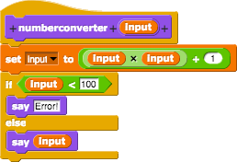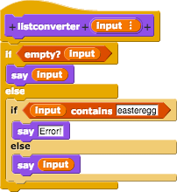

**numberconverter listconverter**

|  |  |
| --- | --- |
| *Domain:*  *Values:* | *Domain:*  *Values:* |

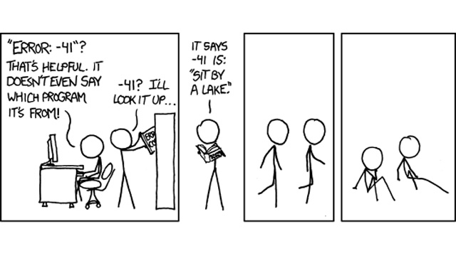

Student ID Number: ________________

**Question 9: *Don’t Let the Code Bugs Bite…*** (4 pts, 15 min)

We are trying to write a block that given an item and a list, will return a new list with the item added to the front. Unfortunately, there is a bug.

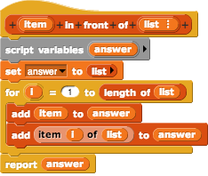



a) What does return?

|  |
| --- |
|  |

b) Give an example of values for **item** and **list** for which this code works correctly, despite the bug.

|  |
| --- |
|  |

c) Describe what you would change so that the block will work correctly for all inputs.

|  |
| --- |
|  |

d) What is the runtime of this block, as a function of the size of the list? (Circle one)

|  |
| --- |
| Constant        Logarithmic        Linear        Quadratic        Cubic        Exponential |

Student ID Number: ________________

**Question 10: *Pick the Right Tool for the Job!*** (5 pts, 15 min)

a) Describe what this block does in one sentence or less.

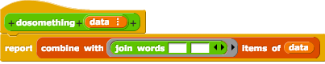

|  |
| --- |
|  |

b)

|  |  |  |  |
| --- | --- | --- | --- |
| For each of the following problems, we want to know *which* of the three Higher Order Functions (HOFs) on the right should be used to solve it efficiently, and if more than one are used, *in what order* they are evaluated. (Remember, inner blocks get run first.)  In solving the problem, there may be extra helper functions that are necessary to solve the problem, but we only care about these 3 functions on the right.  **https://lh6.googleusercontent.com/Q_8a_Sa-At2OcraBGkfB-MWJ7b4v6qp1EGQdVcYzzNgDS78MyFVFZQ5b0y9NFJzVORSuqkBPx_1EUuD-oVUIvxQpfn3WOOtyjwh4ulK3btZoHM8VgpdxjlrkZIytLI0uew**  **We’ve shown the first one as an example, where the data passes through keep (the inner block, #1) first, then into the map (the outer block, #2).   If only one HOF is needed, just put a 1 in that entry.** | https://lh3.googleusercontent.com/JH-svi6aM4BojkSrfaPCktTCD4P6gvgU7UR0MPxv4jaoU-aUEF9OaLik3GW_jPvUTP0wd2WYBfLijYhMw1pRrGi7YpokidXtfstJcM4H1TOTAU83rgCDEDhEZ_El8kaznQ | https://lh5.googleusercontent.com/KyenugRhP1mGGDnbgZ2oD2whMetKVgfPVksd6GocEgUTkrE2d-TlmaYwRrMGUcnsvPe1KwRkK0857bCzIZknkyZfe13LI4Ox2AJhxwcukxD3X_VF5cdgFyhDBcmwYEw96A | https://lh5.googleusercontent.com/tAlUfaMSccpOZrHbUy8pPBQgR3bMXr8BLSMEe9QPoTGkj6k-pu2fUx4Albswm1sUGFhQ0cn8OCwzXnJ7OKgsknFVnbrhM7NRL7PDZxqP5elRNj1QBNBrJ6X7oNKjR8_Pcw |
| https://lh5.googleusercontent.com/omft8hQAMsCND7iJTuBx0tBmgQ943DNIi9srAxihDwZlxHsvo5SqJVO_y_pQCNuPtdWRlvmoB24SKXOwgWr9zM-DilWgrbsOP9y96YC5Bm6jc-zYskslH1do7xjhXylsqw | **2** | **1** |  |
| Given a list of the TAs and the helper functions, **isUpperClassman**, which reports if the TA is or isn't an upperclassman, and **averageSleep**, which reports the number of hours the TA sleeps in a given week on average, **report the total number of hours the upperclassman TAs sleep in a typical week.** |  |  |  |
| Given a list of Cal and Stanford students' (non-inflated) GPAs, **return all of the GPAs in a list that are above the average values of the list.** You are not given a helper function to compute the average of the list here. (Hint: There should be no Stanford students in the returned list). |  |  |  |

Student ID Number: ________________

**Doodle/Notes/Extra Space:**

|  |
| --- |
|  |